Chapter 3: Diagnostics and Remedial Measures

3.1 Diagnostics for predictor variable

For the predictor variable, examine summary statistics, box plots, dot plots, or histograms to determine:

- Range of X values (don’t want to predict Y for an X value outside of the values in the data set).
- Look for outlying values which may have a strong influence on the sample regression model (see Chapter 10) or are data entry errors.
- While KNN focus on the predictor variable here, it may be good to also do this for the response variable as well to make sure there are no data entry errors.

Example: HS and College GPA (HS_college_GPA_ch3.R)

> #Read in the data
> gpa<-read.table(file =
"C:\\chris\\UNL\\STAT870\\Chapter1\\gpa.txt",
header=TRUE, sep = "")
> head(gpa)
HS.GPA College.GPA
1 3.04 3.1
2 2.35 2.3
3 2.70 3.0
4 2.05 1.9
5 2.83 2.5
6 4.32 3.7

>###################################################
> # Section 3.1 - Diagnostics for predictor variable
>
> #Examine range, mean, ...
> summary(gpa)
HS.GPA College.GPA
Min. :0.830 Min. :1.400
1st Qu.:2.007 1st Qu.:1.975
Median :2.370 Median :2.400
Mean :2.569 Mean :2.505
3rd Qu.:3.127 3rd Qu.:3.025
Max. :4.320 Max. :3.800

> #Box and dot plot for X
> par(mfrow = c(1,2)) #1 row and 2 columns of plots for a
graphics window
> boxplot(x = gpa$HS.GPA, col = "lightblue", main = "Box
plot", ylab = "HS GPA", xlab = " ")
> set.seed(1280)
> #Jitter option will randomly move in the x-axis
direction the points to try to avoid overlaying –
setting a seed here forces the exact same jittering
every time the code is run
> stripchart(x = gpa$HS.GPA, method = "jitter", vertical
= TRUE, pch = 1, main = "Dot plot",
ylab = "HS GPA")

> #Box and dot plot for Y
> boxplot(x = gpa$College.GPA, col = "lightblue", main = "Box
plot", ylab = "College GPA", xlab = " ")
> set.seed(1280)
> stripchart(x = gpa$College.GPA, method = "jitter", vertical =
TRUE, pch = 1, main = "Dot plot", ylab = "College GPA")
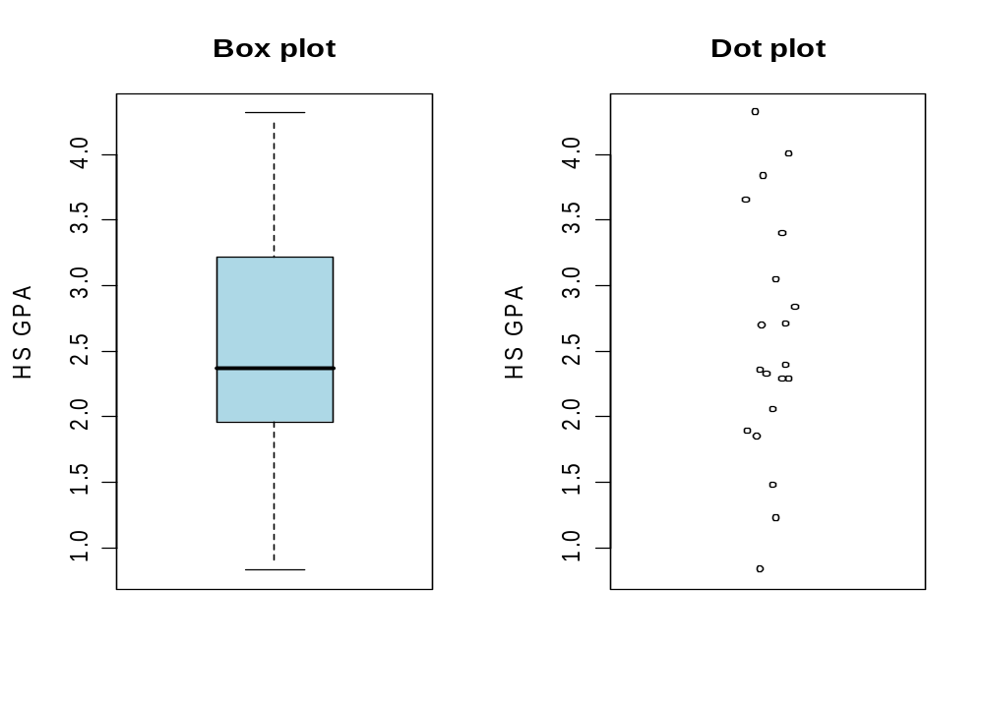

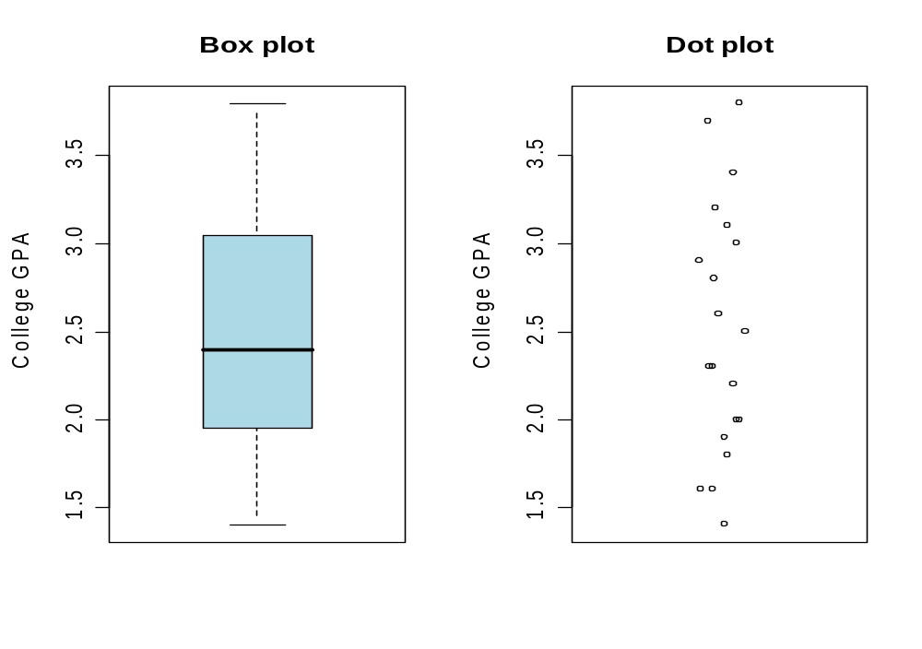

Summary:
- Range of X values: X=0.83 to 4.32
- Look for outlying values: None
- Data entry errors? None
- What would the plots look like if there was reason to be concerned about the data?
- Note that KNN use a different definition of what a “dot plot” is – see plot a. on p. 101

3.2 Residuals

Population model:

Y_{i}=β₀+β₁X_{i}+ε_{i}

where
β₀ and β₁ are parameters
X_{i} are known constants
ε_{i} ~ independent N(0,σ²)

Note that the above equation can be rewritten as
ε_{i}=Y_{i}-β₀-β₁X_{i}

To examine the assumption about the ε_{i}’s, use their estimated quantities: 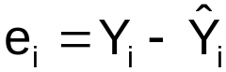. If the assumption about the ε_{i} is approximately true, then the e_{i} should have similar properties as the ε_{i}. Thus, we will be performing a “residual analysis”.

Properties of e_{i}
- 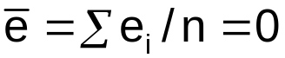
- The variance of the e_{i} can be approximated by 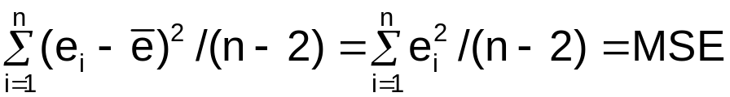
- e_{i} are not independent random variables – involve 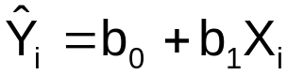. If sample size is large enough with respect to the number of parameters in the model, the dependency is “relatively unimportant and can be ignored for most purposes.”

Semistudentized residuals

Remember from Chapter 2 that a “standardized quantity is:

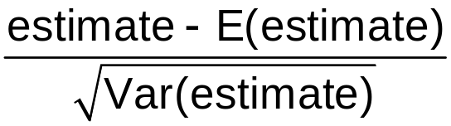 which can often be treated as a N(0,1).

A studentized quantity replaces the unknown quantities with estimates.

The semistudentized residuals are
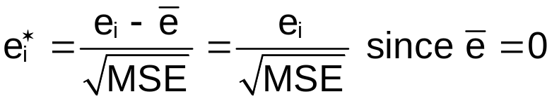.
The reason for the “semi” is the estimate of the variance of e_{i} is not quite MSE. See p. 394 of KNN for “studentized” residuals.

Departures from the model assumptions to be investigated using residuals are:

- The regression model is not linear
- The error variance is not constant
- ε_{i} are not independent
- The model fits all but one or a few outlier observations
- ε_{i} are not distributed normally
- Additional important predictor variables have been excluded from the model

Why are we interested in detecting these departures from the model’s assumption?

Inferences from the sample to the population (like hypothesis testing) may be incorrect if the model’s assumptions are not satisfied.

3.3 Diagnostics for residuals and 3.9 Transformations

- The regression model is not linear:

Assume this relationship: E(Y_{i})=β₀+β₁X_{i}

What if we do not have a linear relationship? How can we detect this?

Plot e_{i} vs. X_{i}
- If the points on a plot are randomly scattered about in no particular pattern, the variable probably is specified correctly in the model
- If the points on a plot exhibit a pattern, the variable is misspecified in the model. The pattern usually will suggest the correct specification of the variable.
- Note that in simple linear regression, a plot of e_{i} vs. 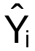 will give the same information. This will no longer be true in multiple linear regression.

Example: Predicting peak power load (power_load.R)

Power companies have to able to predict the peak power load at their various stations to operate efficiently. The peak power load is the maximum amount of power that must be generated each day to meet demand. Suppose a power company located in the southern part of the United States decides to model daily peak power load, Y, as a function of the daily temperature, X, and the model is to be constructed for the summer months when demand is the greatest. A random sample of 25 summer days is selected

Part of the R code and output

> #Read in the data
> power.load<-read.table(file =
"C:\\chris\\UNL\\STAT870\\Chapter3\\power.txt",
header=TRUE, sep = "")
> head(power.load)
load temp
1 96.5 67
2 101.6 67
3 96.3 68
4 92.5 71
5 103.9 74
6 100.9 76

> tail(power.load)
load temp
20 153.2 97
21 150.1 98
22 151.9 100
23 143.6 100
24 178.2 106
25 189.3 108

> plot(x = power.load$temp, y = power.load$load, xlab =
"Temperature", ylab = "Power load", main = "Power
load vs. Temperature", col = "black", pch = 1,
panel.first = grid(col = "gray", lty = "dotted"))

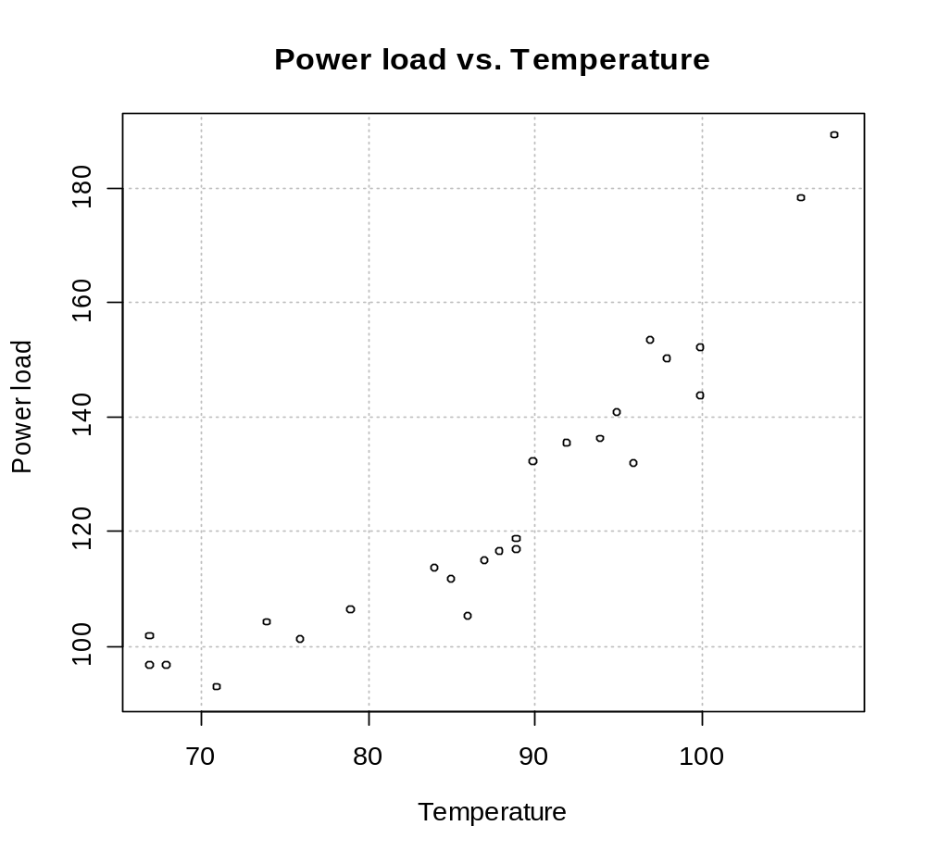
Notice the non-linear trend above.

> mod.fit<-lm(formula = load ~ temp, data = power.load)
> sum.fit<-summary(mod.fit)
> sum.fit

Call:
lm(formula = load ~ temp, data = power.load)

Residuals:
Min 1Q Median 3Q Max
-17.482 -9.205 -0.435 5.036 23.236

Coefficients:
Estimate Std. Error t value Pr(>|t|)
(Intercept) -47.3935 15.6677 -3.025 0.00603 **
temp 1.9765 0.1776 11.128 9.82e-11 ***
---
Signif. codes: 0 '***' 0.001 '**' 0.01 '*' 0.05 '.' 0.1 ' ' 1

Residual standard error: 10.32 on 23 degrees of freedom
Multiple R-Squared: 0.8433, Adjusted R-squared: 0.8365
F-statistic: 123.8 on 1 and 23 DF, p-value: 9.817e-11

> #e.i vs. X.i
> plot(x = power.load$temp, y = mod.fit$residuals, xlab =
"Temperature", ylab = "Residuals", main =
"Residuals vs. Temperature", col = "black", pch =
1, panel.first = grid(col = "gray", lty =
"dotted"))
> abline(h = 0, col = "red")
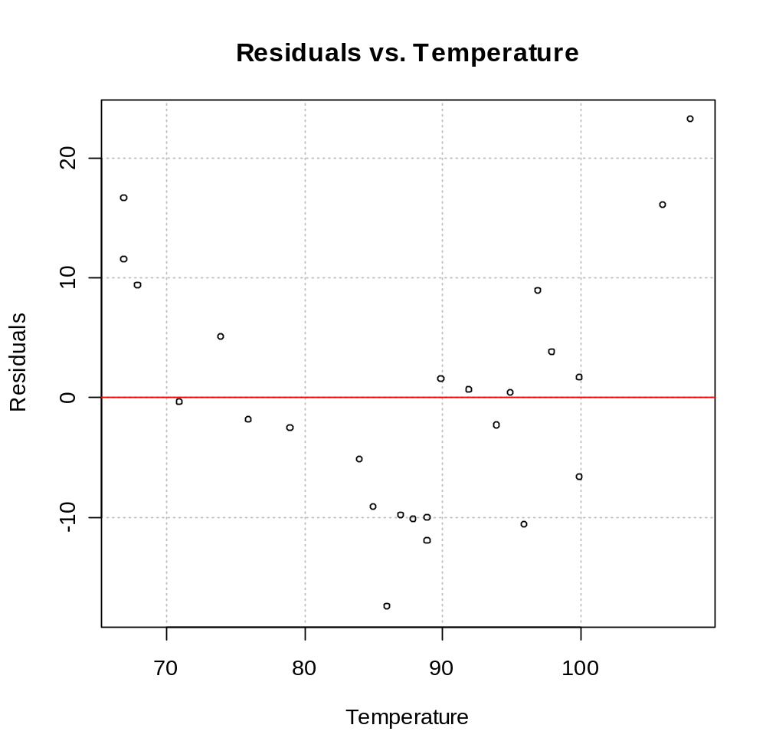
Notice the pattern in the residuals. This suggests a transformation of temperature should be done. In particular, a X² transformation. Below is the same scatter plot with the estimated regression line on it.

> #Scatter plot with sample model
> plot(x = power.load$temp, y = power.load$load, xlab =
"Temperature", ylab = "Power load", main = "Power
load vs. Temperature", col = "black", pch = 1,
panel.first = grid(col = "gray", lty = "dotted"))
> curve(expr = mod.fit$coefficients[1] +
mod.fit$coefficients[2]*x, col = "red", lty =
"solid", lwd = 1, add = TRUE, xlim =
c(min(power.load$temp), max(power.load$temp)))
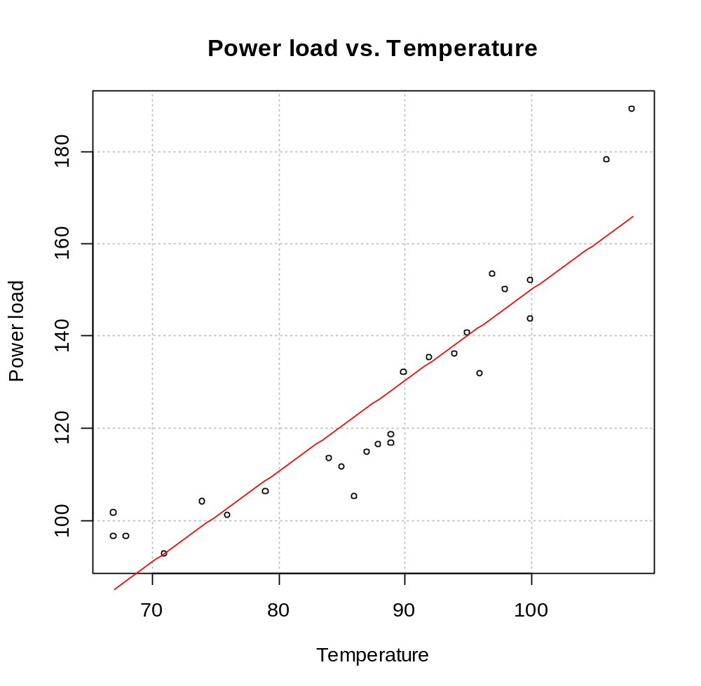
Notice that there appears to be a quadratic pattern to the points which suggests that the model should include a X² term. Also, examine how the shape of the e_{i} vs. X_{i} plot can be seen from examining this plot (i.e., positive residuals near 70 and 110 and mostly negative residuals in between).

Suppose I add temperature² to the model.

> mod.fit2<-lm(formula = load ~ temp + I(temp^2), data = power.load)
> sum.fit2<-summary(mod.fit2)
> sum.fit2
Call:
lm(formula = load ~ temp + I(temp^2), data = power.load)

Residuals:
Min 1Q Median 3Q Max
-10.42910 -2.17790 -0.01562 3.17590 9.64893

Coefficients:
Estimate Std. Error t value Pr(>|t|)
(Intercept) 385.048093 55.172436 6.979 5.27e-07 ***
temp -8.292527 1.299045 -6.384 2.01e-06 ***
I(temp^2) 0.059823 0.007549 7.925 6.90e-08 ***
---
Signif. codes: 0 '***' 0.001 '**' 0.01 '*' 0.05 '.' 0.1 ' ' 1

Residual standard error: 5.376 on 22 degrees of freedom
Multiple R-Squared: 0.9594, Adjusted R-squared: 0.9557
F-statistic: 259.7 on 2 and 22 DF, p-value: 4.991e-16

> #e.i vs. X.i
> par(mfrow=c(1,1))
> plot(x = power.load$temp, y = mod.fit2$residuals, xlab
= "Temperature", ylab = "Residuals", main = "Residuals
vs. Temperature", col = "black", pch = 1, panel.first
= grid(col = "gray", lty = "dotted"))
> abline(h = 0, col = "red")

> #Scatter plot with sample model
> plot(x = power.load$temp, y = power.load$load, xlab =
"Temperature", ylab = "Power load", main = "Power
load vs. Temperature", col = "black", pch = 1,
panel.first = grid(col = "gray", lty = "dotted"))
> curve(expr = mod.fit2$coefficients[1] +
mod.fit2$coefficients[2]*x +
mod.fit2$coefficients[3]*x^2, col = "red", lty =
"solid", lwd = 1, add = TRUE, xlim =
c(min(power.load$temp), max(power.load$temp)))
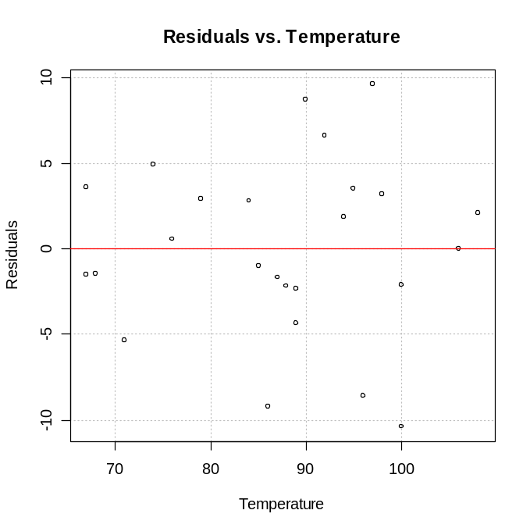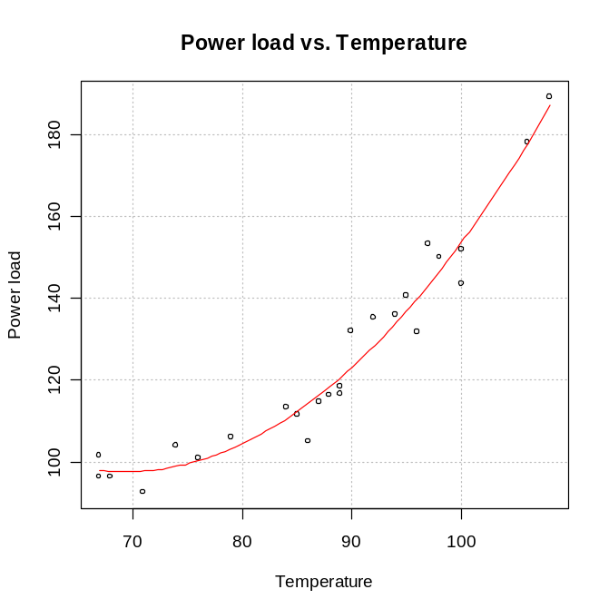
The sample regression model is now where Y = power load and X = temperature. The e_{i} vs. temperature plot no longer shows any patterns. Note that “polynomial regression” will be discussed in KNN on p. 219 and reasoning will be given for why X still remained in the model.

Example: nonlin_relation_only.R

I simulated data from a population regression model to illustrate various situations. Remember that our regular population model is

Y_{i} = β₀ + β₁X_{i} + ε_{i} with ε_{i} ~ independent N(0,σ²)

Suppose we let β₀ = 2, β₁ = 10, σ² = 25². Using the rnorm() function in R and set of X_{i}’s, we can obtain ε_{i} for i = 1,…, n and then use Y_{i} = 2 + 10X_{i} + ε_{i} to obtain Y_{i}. This is a very good example of showing what a population regression model represents.

> #########################################################
> #Simulate data

> X<-seq(from = 1, to = 99, by = 2)
> set.seed(1719) #Set seed so that I can reproduce the
exact same results
> epsilon1<-rnorm(n = length(X), mean = 0, sd = 25)
#Simulate from N(0,25^2)
> epsilon2<-rnorm(n = length(X), mean = 0, sd = 5)
#Simulate from N(0,5^2)
> beta0<-2
> beta1<-10

> #Create response variable - notice how the mix of
vectors and scalar quantities in creating the Y's
> Y1<-beta0 + beta1*X + epsilon1 #linear
> Y2<-beta0 + beta1*sqrt(X) + epsilon2 #non-linear

> head(data.frame(Y1, X))
Y1 X
1 4.38882 1
2 42.64053 3
3 49.99518 5
4 48.91153 7
5 148.61576 9
6 123.26733 11

Population regression model #1: Suppose Y_{i} = 2 + 10∗X_{i} + ε_{i} where ε_{i} ~ independent N(0,25). Fifty observations from this model were simulated to produce the plots below. The sample model is 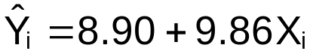

> mod.fit<-lm(formula = Y1 ~ X) #Do not need data =
option since X and Y
exist outside of one
data set
> mod.fit$coefficients
(Intercept) X
8.898149 9.859957

> par(mfrow = c(1,2))
> plot(x = X, y = Y1, main = "Y1 vs. X", panel.first =
grid(col = "gray", lty = "dotted"))
> curve(expr = mod.fit$coefficients[1] +
mod.fit$coefficients[2]*x, col = "red", add =
TRUE, xlim = c(min(X), max(X)))
> plot(x = X, y = mod.fit$residuals, ylab = "Residuals",
main = "Residuals vs. X", panel.first = grid(col =
"gray", lty = "dotted"))
> abline(h = 0, col = "red")

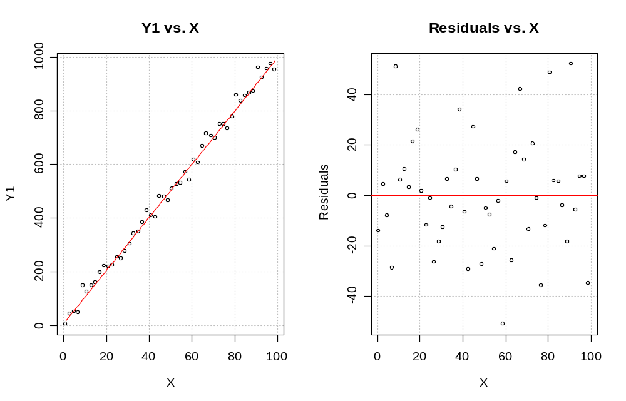

Note that points on the scatter plot seem to be randomly scattered about the sample regression model’s line. Also, there is no pattern in the plot of e_{i} vs. X_{i}. This is an example where there is NOT a problem with the linearity of the regression function.

Population regression model #2: Suppose Y_{i} = 2 + 10*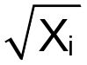 + ε_{i} where ε_{i} ~ independent N(0,5). Fifty observations from this model were generated to produce the plots below. The sample model is 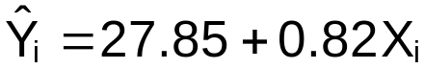 (Note that only X is used in the sample model).

> mod.fit<-lm(formula = Y2 ~ X)
> mod.fit$coefficients
(Intercept) X
27.8537113 0.8205562

> plot(x = X, y = Y2, main = "Y2 vs. X", panel.first =
grid(col = "gray", lty = "dotted"))
> curve(expr = mod.fit$coefficients[1] +
mod.fit$coefficients[2]*x, col = "red", add =
TRUE, xlim = c(min(X), max(X)))
> plot(x = X, y = mod.fit$residuals, ylab = "Residuals",
main = "Residuals vs. X", panel.first = grid(col =
"gray", lty = "dotted"))
> abline(h = 0, col = "red")

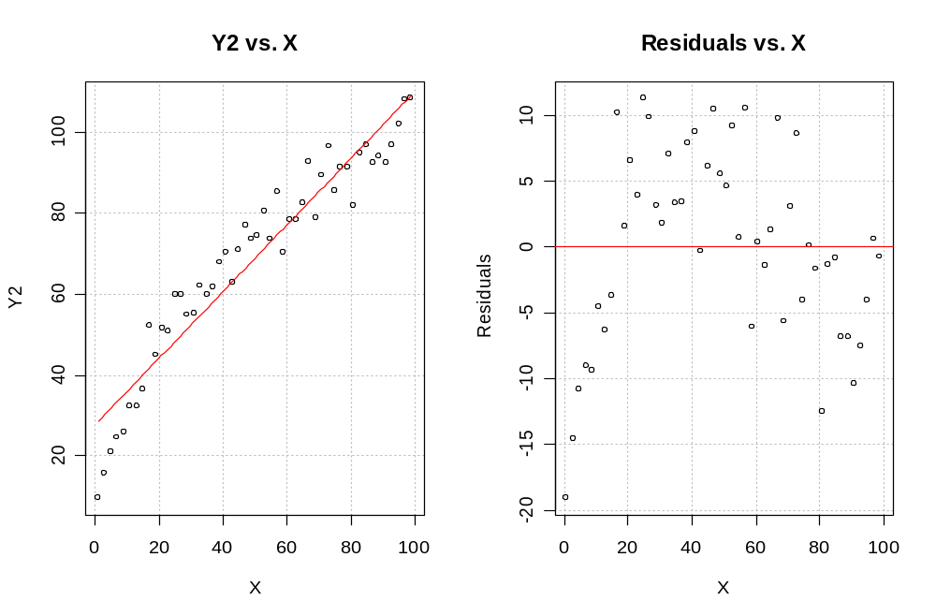

Note that the points on the scatter plot are NOT randomly scatter about the estimated regression line. There is a pattern in the plot of e_{i} vs. X_{i}. This is an example where there is a problem with the linearity of the regression function. This particular “shape” may indicate a 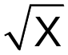 or log₁₀(X) transformation is needed (See p. 130, plot a).

Suppose the transformation is tried. The sample model is 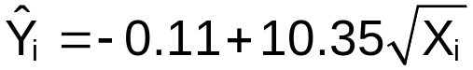 and much closer to the population model.

> #Try a transformation
> mod.fit<-lm(formula = Y2 ~ sqrt(X))
> mod.fit$coefficients
(Intercept) sqrt(X)
-0.1090976 10.3460496

> plot(x = X, y = Y2, main = "Y2 vs. X", panel.first =
grid(col = "gray", lty = "dotted"))
> curve(expr = mod.fit$coefficients[1] +
mod.fit$coefficients[2]*sqrt(x), col = "red", add
= TRUE, xlim = c(min(X), max(X)))
> plot(x = X, y = mod.fit$residuals, ylab = "Residuals",
main = "Residuals vs. X", panel.first = grid(col =
"gray", lty = "dotted"))
> abline(h = 0, col = "red")
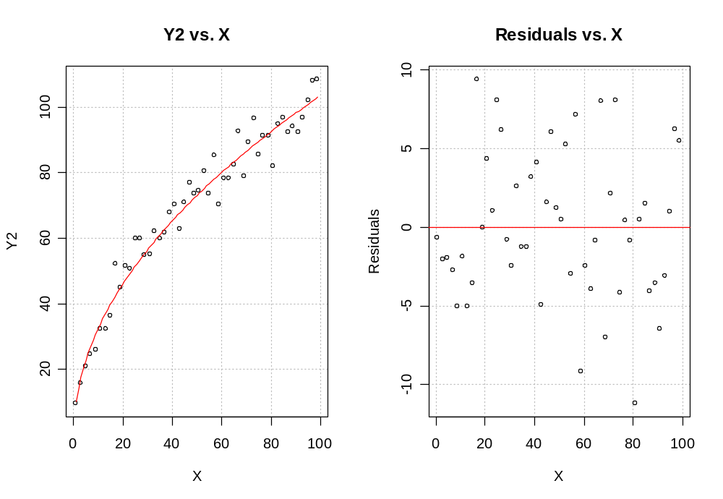
Population regression model #3: Suppose Y_{i} = 2 + 10*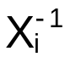 + ε_{i} where ε_{i} ~ independent N(0,5). One hundred observations from this model were generated to produce the plots below. The sample model is 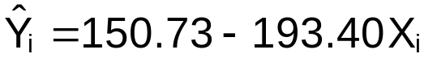 (Note that only X is used in the sample model).

> X<-seq(from = 0.01, to = 1, by = 0.01)
> set.seed(1278)
> epsilon3<-rnorm(n = length(X), mean = 0, sd = 5)
> beta0<-2
> beta1<-10

> #Create response variable
> Y3<-beta0 + beta1*1/X + epsilon3 #non-linear

> mod.fit<-lm(formula = Y3 ~ X)
> mod.fit$coefficients
(Intercept) X
150.7347 -193.4018

> plot(x = X, y = Y3, main = "Y3 vs. X", panel.first =
grid(col = "gray", lty = "dotted"))
> curve(expr = mod.fit$coefficients[1] +
mod.fit$coefficients[2]*x, col = "red", add =
TRUE, xlim = c(min(X), max(X)))
> plot(x = X, y = mod.fit$residuals, ylab = "Residuals",
main = "Residuals vs. X", panel.first = grid(col =
"gray", lty = "dotted"))
> abline(h = 0, col = "red")
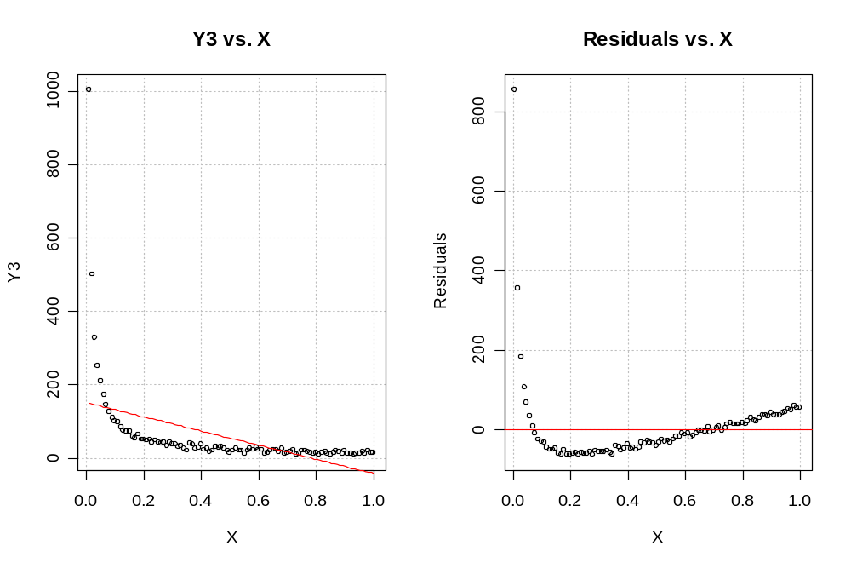
Note that the points on the scatter plot are NOT randomly scatter about the sample regression model’s line. There is a pattern in the plot of e_{i} vs. X_{i}. This is an example where there is a problem with the linearity of the regression function. This particular “shape” is indicative of using a 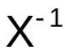 or e^{-X} transformation (where e≈2.71) – see p. 130, plot c.

> #Try a transformation
> mod.fit<-lm(formula = Y3 ~ I(1/X))
> mod.fit$coefficients
(Intercept) I(1/X)
1.166172 10.005176

> plot(x = X, y = Y3, main = "Y3 vs. X", panel.first =
grid(col = "gray", lty = "dotted"))
> curve(expr = mod.fit$coefficients[1] +
mod.fit$coefficients[2]*1/x, col = "red", add =
TRUE, xlim = c(min(X), max(X)))
> plot(x = X, y = mod.fit$residuals, ylab = "Residuals",
main = "Residuals vs. X", panel.first = grid(col =
"gray", lty = "dotted"))
> abline(h = 0, col = "red")
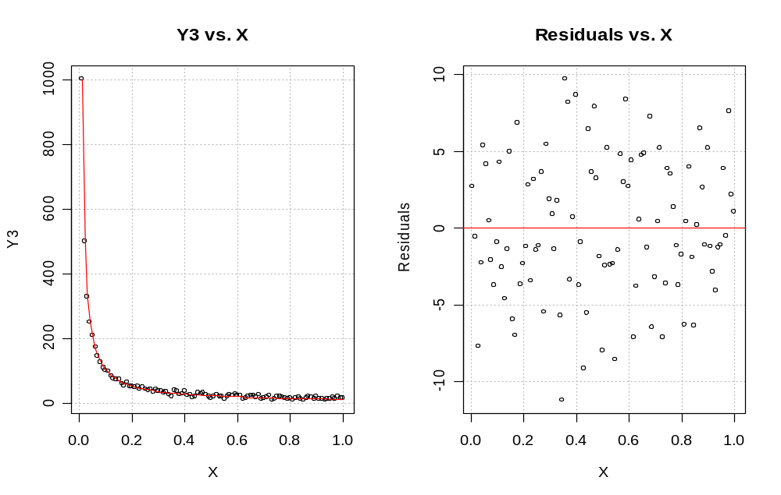
See plot b on p. 130 of KNN for a another example of these plots and types of transformations.

- The error variance is not constant

Y_{i}=β₀+β₁X_{i}+ε_{i}

where ε_{i} ~ independent N(0,σ²)

How can we tell if the variance for ε_{i} is σ² (i.e., constant) for all i=1,…,n? Typically, if the assumption does not hold true, σ² is a function of X or Y. A plot of e_{i} vs. can be used to detect this.

Below are two examples of plotting Y vs. X to show what the constant variance assumption looks. Although this type of plot can be used in simple linear regression to detect the constant variance problem, this type of plot will not be available in multiple regression (Chapter 6 and beyond). Therefore, we use a plot of e_{i} vs. to usually detect this problem.

Example 1: Constant variance assumption holds for simple linear regression.
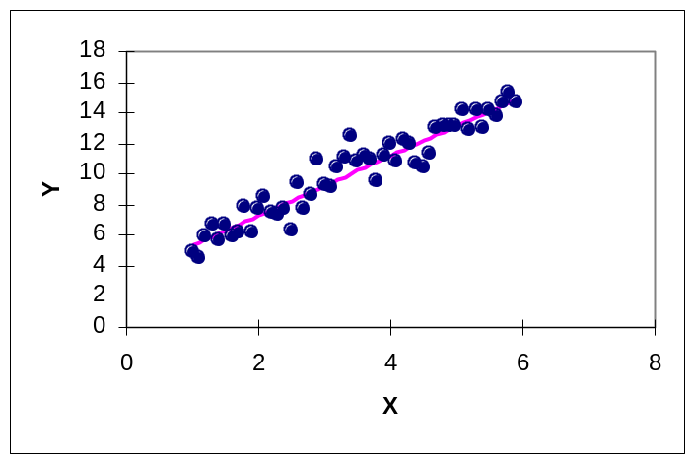

The variability of the Y’s around the sample regression model’s line appears to be the same.

Example 2: Constant variance assumption does not hold for simple linear regression.
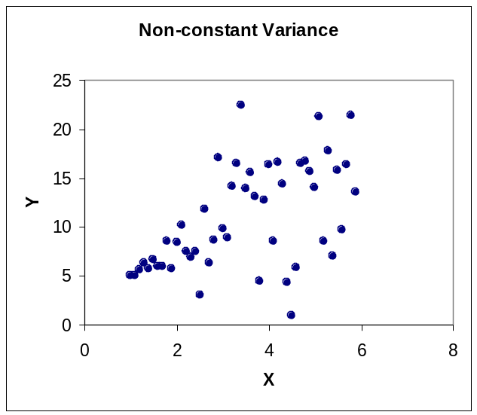
Notice how the points tend to spread (fan) out in the Y direction as X changes.

A funnel shape or oval shape in a plot of e_{i} vs. denotes a violation of the equal variances assumption.
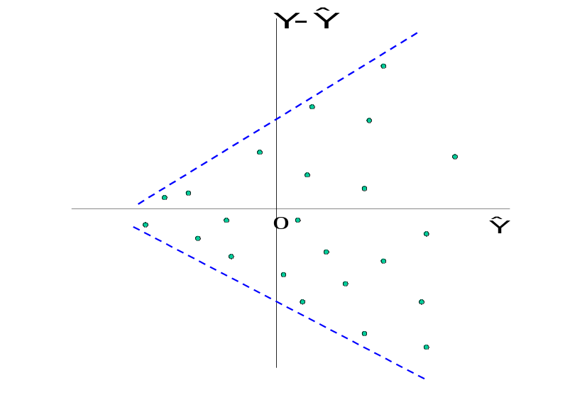

Using transformations of the response variable (like log(Y), 1/Y, and 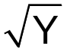) is one way to try to solve a nonconstant variance problem. A number of transformations can be tried and the same plot (with the transformed predicted Y) can be constructed to see if the pattern still exists. If it does not, the transformation chosen stabilizes the variance. See Figure 3.15 on p. 132 for a graphical guide for what types of transformations to use. The Box-Cox family of transformations is a more formal way to find the correct transformation and it will be discussed next. Lastly, weighted least squares, where weights are proportional to the nonconstant variance for each ε_{i}, can be used and this will be discussed in Section 11.1.

Box-Cox transformations

To fully understand this procedure, you need to know what maximum likelihood estimation represents. You will be responsible here for being able to apply it only.

Consider the transformed regression model of

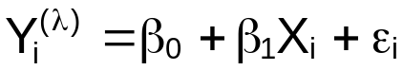

where 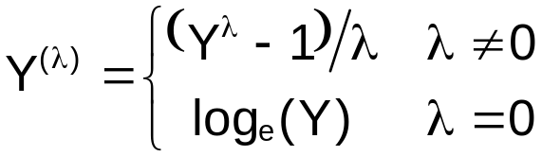 and Y > 0. This is the most common definition as given by Box and Cox (1964). Due to the structure of a linear regression model, one can equivalently express this as

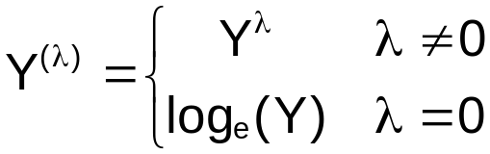,

which KNN does. With this model, there is an extra parameter, λ, that must be estimated. Through maximum likelihood estimation, λ, β₀, β₁, and σ² are all estimated. The estimated λ then suggests the type of transformation to use. For example, if λ is estimated to be ½, use the square root transformation. Notice if λ is estimated to be 1, no transformation is needed. The estimate for λ is commonly searched for in the range of
-2 to 2.

Example: Trees data from MASS package (trees.R)

This data is in the MASS package. The MASS package contains a set of functions and data sets used with the Modern Applied Statistics with S book by Venables and Ripley. See help(trees) for specific information on the data set.

Let Y = volume and X = height for the trees in the sample.

> library(MASS) #Location of trees data and boxcox()
function
> head(trees)
Girth Height Volume
1 8.3 70 10.3
2 8.6 65 10.3
3 8.8 63 10.2
4 10.5 72 16.4
5 10.7 81 18.8
6 10.8 83 19.7

> mod.fit<-lm(formula = Volume ~ Height, data = trees)
> summary(mod.fit)

Call:
lm(formula = Volume ~ Height, data = trees)

Residuals:
Min 1Q Median 3Q Max
-21.274 -9.894 -2.894 12.067 29.852

Coefficients:
Estimate Std. Error t value Pr(>|t|)
(Intercept) -87.1236 29.2731 -2.976 0.005835 **
Height 1.5433 0.3839 4.021 0.000378 ***
---
Signif. codes: 0 '***' 0.001 '**' 0.01 '*' 0.05 '.' 0.1 ' ' 1

Residual standard error: 13.4 on 29 degrees of freedom
Multiple R-Squared: 0.3579, Adjusted R-squared: 0.3358
F-statistic: 16.16 on 1 and 29 DF, p-value: 0.0003784

> #Plot of Y vs. X with sample model
> plot(x = trees$Height, y = trees$Volume, xlab = "Height",
ylab = "Volume", main = "Volume vs. Height",
panel.first = grid(col = "gray", lty = "dotted"))
> curve(expr = mod.fit$coefficients[1] +
mod.fit$coefficients[2]*x, col = "red", lty =
"solid", lwd = 1, add = TRUE, xlim =
c(min(trees$Height), max(trees$Height)))

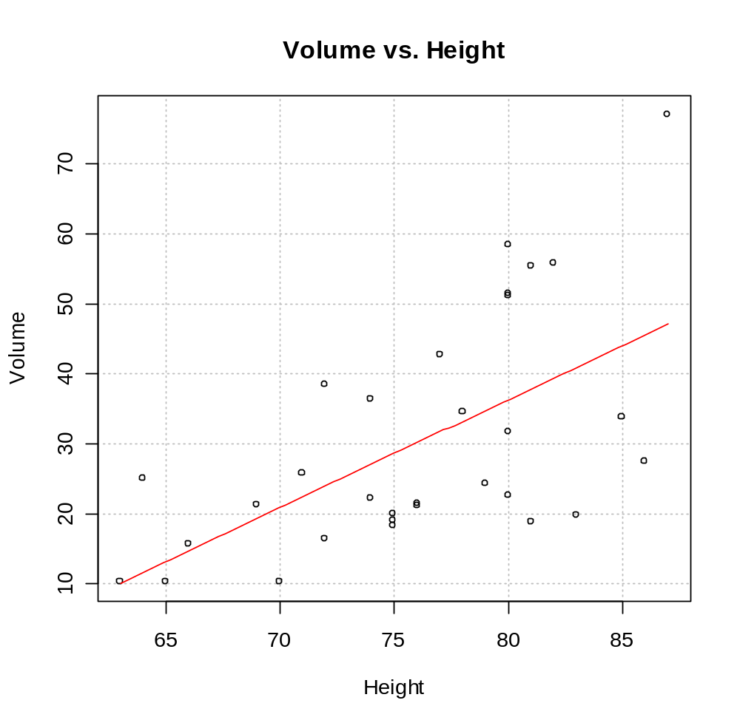

Notice that the variability in the Y_{i}’s increases as X_{i} increases.

> #e.i vs. Yhat.i
> plot(x = mod.fit$fitted.values, y = mod.fit$residuals,
xlab = expression(hat(Y)), ylab = "Residual",
main = expression(paste("Residuals vs. ", hat(Y))),
panel.first = grid(col = "gray", lty = "dotted"))
> abline(h = 0, col = "red")
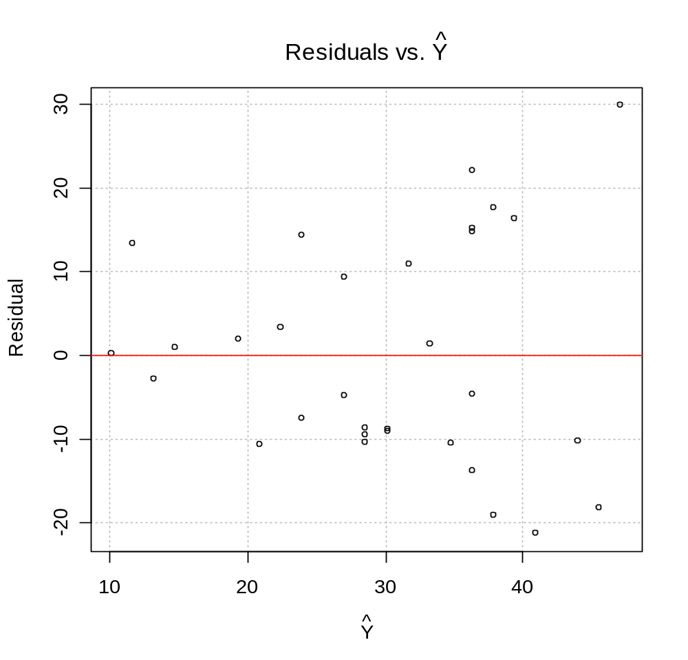
The funnel shape occurs a little here. Based upon this and the Y vs. X plot, it would be of interest to consider a transformation of Y. Also, notice the use of hat(Y) and the expression() function in the plot() function. Use demo(plotmath) for more information about how to get mathematical symbols in plots.

> #Determine lambda.hat – Use getAnywhere(boxcox.default)
if you want to see the function
> save.bc<-boxcox(object = mod.fit, lambda = seq(from = -2,
to = 2, by = 0.01)) #In MASS package
> title(main = "Box-Cox transformation plot") #Another way
to get a title on a plot
> lambda.hat<-save.bc$x[save.bc$y == max(save.bc$y)]
> lambda.hat
[1] -0.19
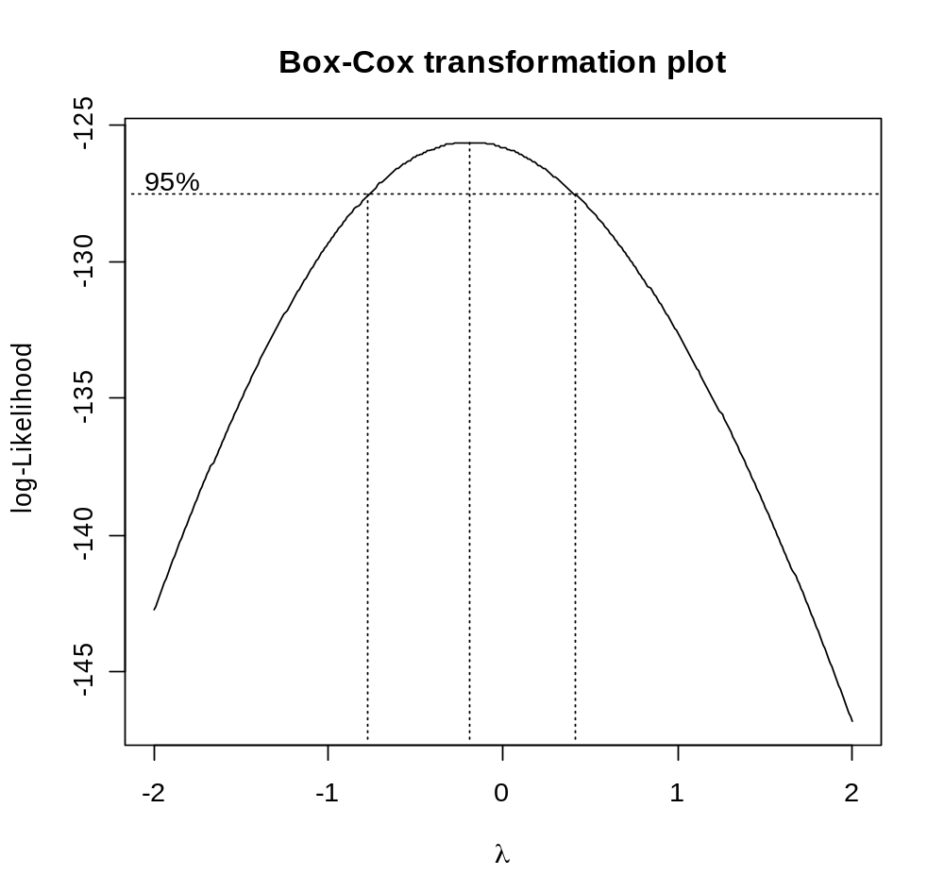

The boxcox() function estimates λ using maximum likelihood estimation. If you have seen this type of estimation before, the above plot should look familiar. Here, it shows the profile log-likelihood function is maximized when λ = -0.19. It also gives a likelihood based 95% confidence interval of about -0.8 to 0.4 for λ. Notice that λ = 0 is in the interval (may want to consider natural log transformation), and notice λ = 1 is not interval (transformation needed). Please make sure to see my code above for how I found 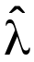 (maximum likelihood estimate) after boxcox() was run.

Using = -0.19 results in the following,

> mod.fit2<-lm(formula = Volume^lambda.hat ~ Height, data
= trees)
> summary(mod.fit2)

Call:
lm(formula = Volume^lambda.hat ~ Height, data = trees)

Residuals:
Min 1Q Median 3Q Max
-0.062972 -0.042188 0.004258 0.028598 0.069320

Coefficients:
Estimate Std. Error t value Pr(>|t|)
(Intercept) 0.959543 0.090273 10.629 1.62e-11 ***
Height -0.005526 0.001184 -4.668 6.38e-05 ***
---
Signif. codes: 0 '***' 0.001 '**' 0.01 '*' 0.05 '.' 0.1 ' ' 1

Residual standard error: 0.04131 on 29 degrees of freedom
Multiple R-Squared: 0.429, Adjusted R-squared: 0.4093
F-statistic: 21.79 on 1 and 29 DF, p-value: 6.375e-05

> plot(x = mod.fit2$fitted.values, y =
mod.fit2$residuals, xlab = expression(hat(Y)^{-
0.19}), ylab = "Residual", main =
expression(paste("Residuals vs. ", hat(Y)^{-0.19})),
panel.first = grid(col = "gray", lty = "dotted"))
> abline(h = 0, col = "red")

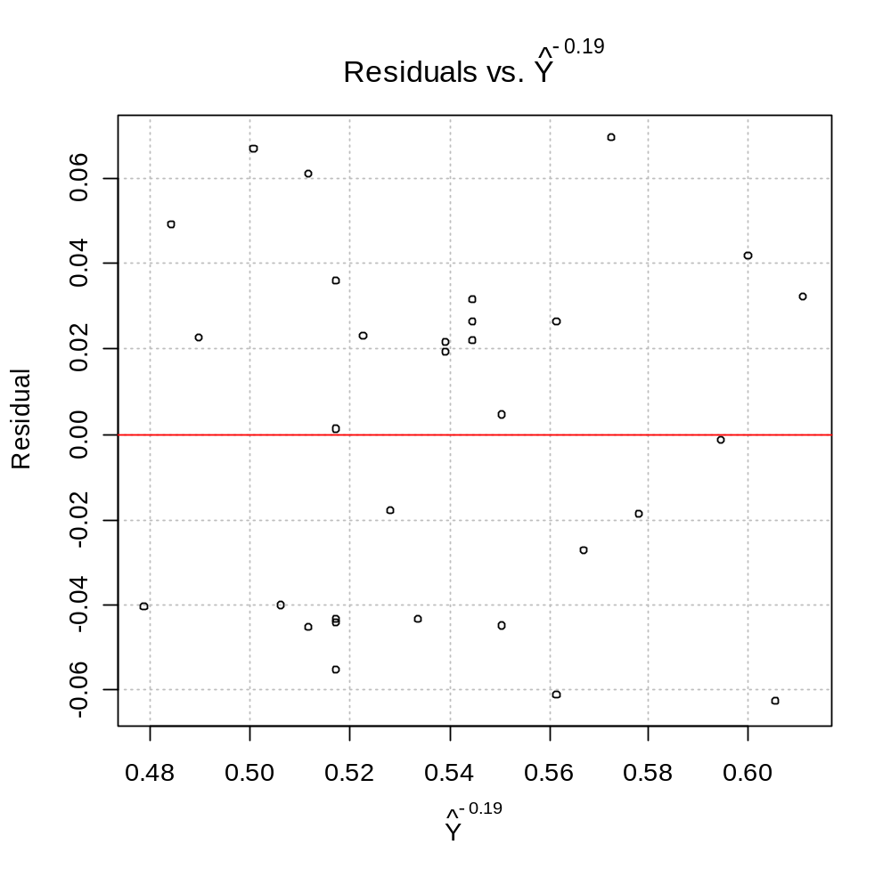
It looks like = -0.19 leads to an approximately constant variance. The sample model can then be expressed as

How would you find ?

Since λ = 0 is in the interval, it may be of interest to try the natural log transformation since this is easier to interpret (and more common).

> mod.fit3<-lm(formula = log(Volume) ~ Height, data =
trees)
> summary(mod.fit3)

Call:
lm(formula = log(Volume) ~ Height, data = trees)

Residuals:
Min 1Q Median 3Q Max
-0.66691 -0.26539 -0.06555 0.42608 0.58689

Coefficients:
Estimate Std. Error t value Pr(>|t|)
(Intercept) -0.79652 0.89053 -0.894 0.378
Height 0.05354 0.01168 4.585 8.03e-05 ***
---
Signif. codes: 0 '***' 0.001 '**' 0.01 '*' 0.05 '.' 0.1 ' ' 1

Residual standard error: 0.4076 on 29 degrees of freedom
Multiple R-Squared: 0.4203, Adjusted R-squared: 0.4003
F-statistic: 21.02 on 1 and 29 DF, p-value: 8.026e-05

> plot(x = mod.fit3$fitted.values, y =
mod.fit3$residuals, xlab = "log(Y)", ylab =
"Residual", main = "Residuals vs. log(Y)",
panel.first = grid(col = "gray", lty = "dotted"))
> abline(h = 0, col = "red")

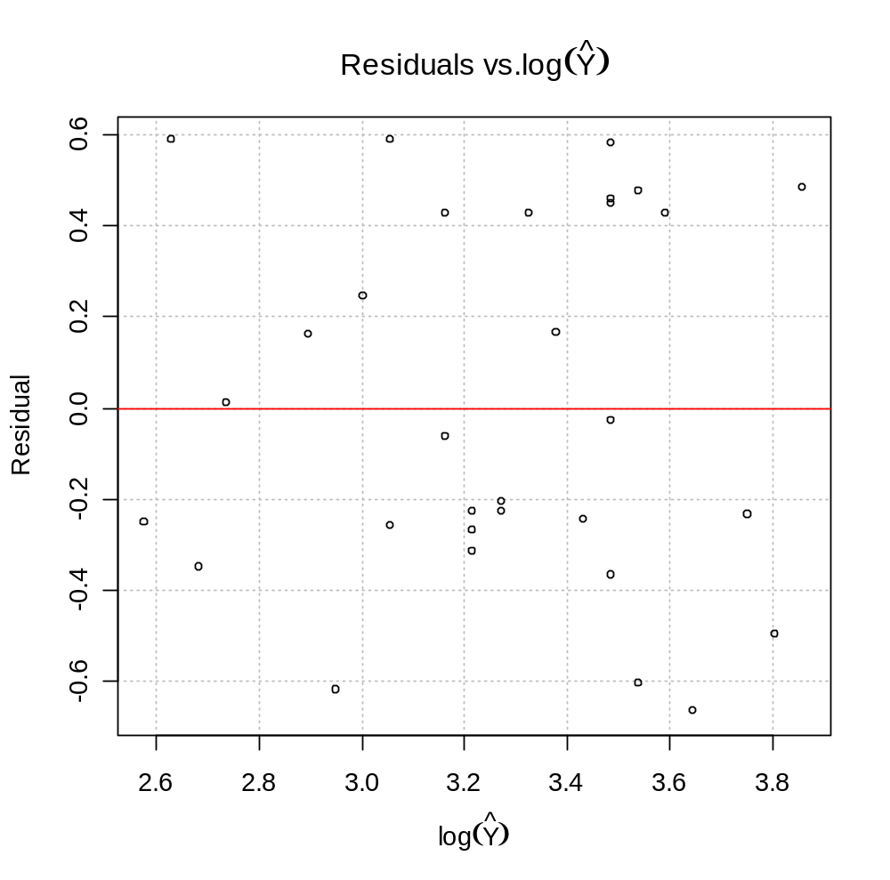
The natural log transformation works as well. This sample model can be expressed as



How would you find ?

Notes:
- The Box-Cox transformation may not work as well for other data sets. It is dependent upon if other parts of the model are correct.
- There is an interesting function called vis.boxcox() in the TeachingDemos package. If you run the function simply as vis.boxcox(), it will simulate data for a simple linear regression model. Plots of Y vs X. and residuals vs. X (not sure what not residuals vs. ) are produced for the simulated data. The user can then interactively choose a λ value to see how it will change these plots. Below is a screen capture from running it once.

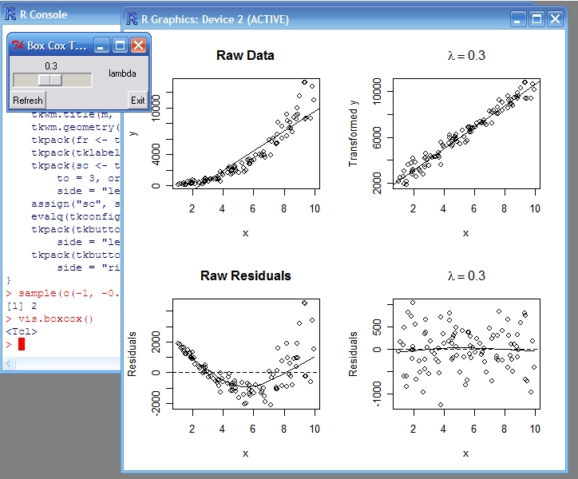

- ε_{i} are not independent

Y_{i}=β₀+β₁X_{i}+ε_{i} where ε_{i} ~ independent N(0,σ²)

When data is collected over time (often X_{i} denotes time), the error terms may not be independent. A “sequence plot of the residuals” can be used to detect this. This plots the residuals from observation number 1 to n in the sequence the data was collected. A pattern in the residuals (i.e., they look correlated) gives evidence that the ε_{i} are not independent.

Example plot:
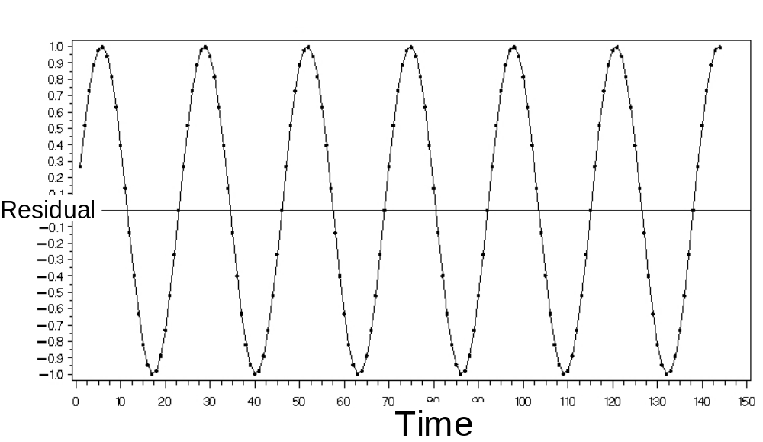

Solution: Use time series analysis methods. See www.chrisbilder.com/ts/schedule.htm for my lecture notes from when I have taught a times series analysis class. The Section 5.5 lecture notes talk about how the gls() function can be used to solve the dependence problems. UNL STAT 971 may discuss this some as well.

- The model fits all but one or a few outlier observations

Outliers: Extreme values; out-of-the-ordinary observations

Want to detect these because:
- Could be data entry error
- Can affect how the sample model fits the data. For example, suppose there is one outlier, the sample model’s line may be pulled toward the corresponding observation in the data set causing a distortion between the relationship of Y and X.

The semistudentized residuals are 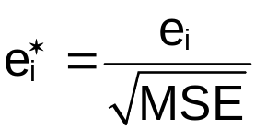. We can treat these as approximately mean 0 and variance 1 random variables. Remember that all data tends to lie ±3(standard deviations) from its mean (see p. 1.49 of notes), we can use 0±3*1 = (-3,3) as an expected range for the semistudentized residuals. Note that KNN says
(-4,4). A residual outside of this range may denote an outlier.

A plot of  vs. (and other plots) can be used to detect these outliers.

Example plot:
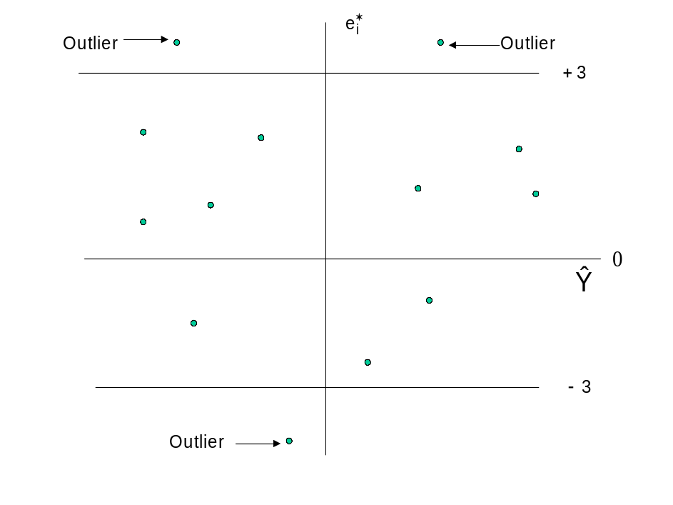
Example: Predicting peak power load (power_load.R)

Continuing the code and output from the last time we examined this data

> semi.stud.resid<-mod.fit$residuals/sum.fit$sigma

> #e.i.star vs. Yhat.i
> par(mfrow = c(1,1))
> plot(x = mod.fit$fitted.values, y = semi.stud.resid,
xlab = expression(hat(Y)), ylab = "Semi-
studentized residuals", main =
expression(paste("Semi-studentized residuals vs.",
hat(Y))), panel.first = grid(col = "gray", lty =
"dotted"), ylim = c(-3,3))
> abline(h = 0, col = "red")
> abline(h = c(-3,3), col = "red", lwd = 2)
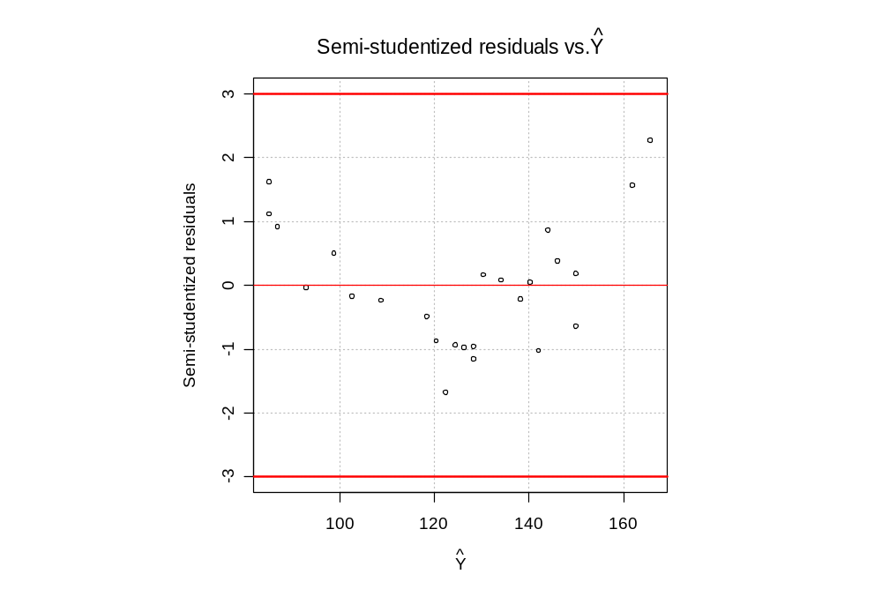

Notice that there are no outliers indicated from the plots (i.e., no semistudentized residuals >3 or <-3). Be careful with implementing this code! I used the ylim option her only so that you could see the lower and upper boundary lines. If there were values outside of this range, the plot would not show them!

What if there is an outlier?
- Check for data entry error
- Could be due to an omission of an important variable from the model (more on this when we get to multiple regression)
- If only a few outliers exist and they are not too extreme, continue with the regression analysis.
- Look for particular characteristics of the outliers that may be the cause (more on this when we get to multiple regression).

- ε_{i} are not distributed normally

Y_{i}=β₀+β₁X_{i}+ε_{i} where ε_{i} ~ independent N(0,σ²)

Small departures from normality for the ε_{i} do not cause major problems. Large departures from normality do!

A histogram with normal distribution overlay and QQ-plot of the e_{i} or should look like a corresponding plot from a normal distribution.

What is a QQ-plot for the normal distribution?

Plot the observed quantiles (ordered data values) vs. what they would be if the data had a normal distribution. For example, in this type of plot the median observed value would be on the y-axis and the median of a normal distribution would be on the x-axis. Please see the upcoming example for more information.

KNN talk about a normal probability plot (p. 110-112). This is mostly the same plot as the QQ-plot.

Example: Predicting peak power load (power_load.R)

Histogram

> #Regular histogram of the semi-studentized residuals
> hist(x = semi.stud.resid, main = "Histogram of semi-
studentized residuals", xlab = "Semi-
studentized residuals")
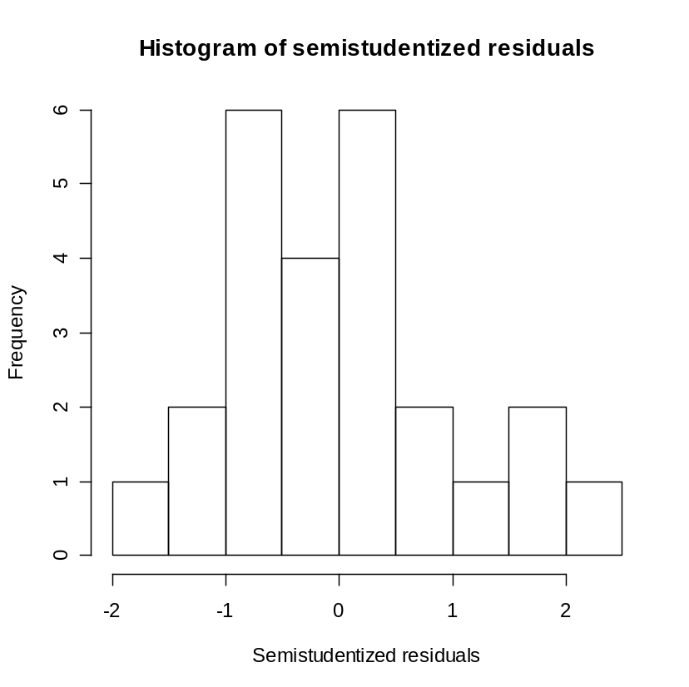

Next is a better plot to assess normality. I changed the y-axis to be frequency/(class width ∗ n) using the freq = FALSE option. This allows one to put the y-axis on the same scale as a probability distribution function, i.e., f(x) = 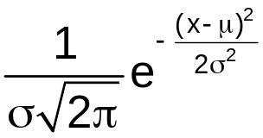 for a normal distribution.

> #Histogram of the semi-studentized residuals with normal
distribution overlay
> hist(x = semi.stud.resid, main = "Histogram of semi-
studentized residuals", xlab = "Semi-
studentized residuals", freq = FALSE)
> curve(expr = dnorm(x, mean = mean(semi.stud.resid), sd
= sd(semi.stud.resid)), col = "red", add = TRUE)
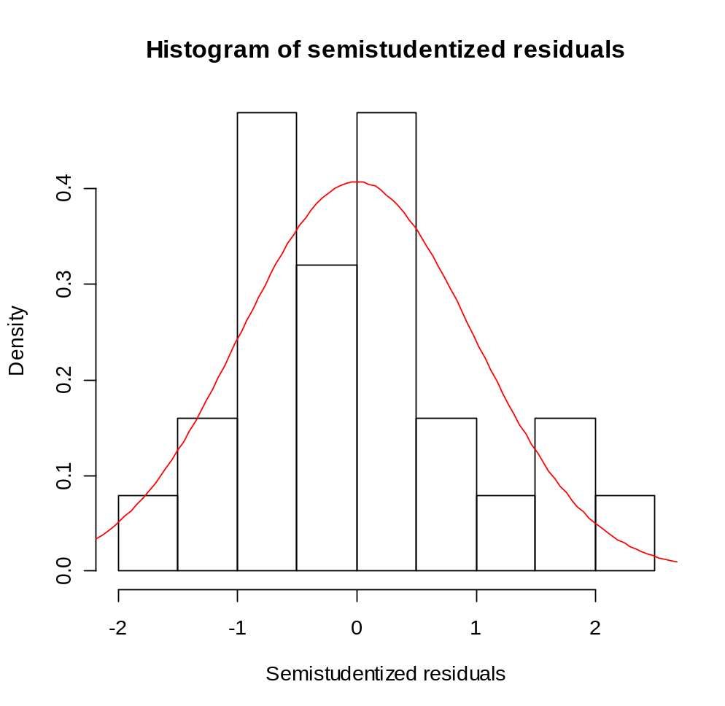
Comments:
- What do you think about normality?
- Would both plots be needed?

QQ-plot

If 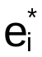 has a normal distribution, then the sorted values should be exactly the same as the quantiles from a normal distribution with the same mean and standard deviation as . Question: What is the mean and approximate standard deviation of ?

NOTE: We will later use in Chapter 10 what are called “studentized residuals” which are better to use because they have a normal distribution with the same variance for i = 1, …, n. Until then, the semistudentized residuals will be good enough to use.

The plot next shows that the values plotted against their normal quantiles. If does follow a normal distribution with a particular mean and variance, these values would be equal. I have plotted a line at a 45° degree angle line (slope = 1) to help you see it.

> n<-length(semi.stud.resid)
> norm.quant<-qnorm(p = seq(from = 1/(n+1), to = 1-
1/(n+1), by = 1/(n+1)), mean = mean(semi.stud.resid),
sd = sd(semi.stud.resid))
> plot(y = sort(semi.stud.resid), x = norm.quant, main =
"QQ-Plot for semi-studentized residuals", ylab =
"Semi-studentized residuals", xlab = "Normal
quantiles", panel.first = grid(nx = NULL, ny =
NULL, col="gray", lty="dotted"))
> abline(a = 0, b = 1, col = "red")

> #What is being plotted above?
> probs<-round(seq(from = 1/(n+1), to = 1-1/(n+1), by =
1/(n+1)),4)
> data.frame(sort.semi.stud.res =
round(sort(semi.stud.resid),2),
norm.quant = round(norm.quant,2), probs)

sort.semi.stud.res norm.quant probs
10 -1.69 -1.73 0.0385
14 -1.16 -1.40 0.0769
19 -1.03 -1.17 0.1154
12 -0.98 -1.00 0.1538
13 -0.97 -0.85 0.1923
11 -0.95 -0.72 0.2308
9 -0.89 -0.60 0.2692

Output edited

2 1.61 1.40 0.9231
25 2.25 1.73 0.9615

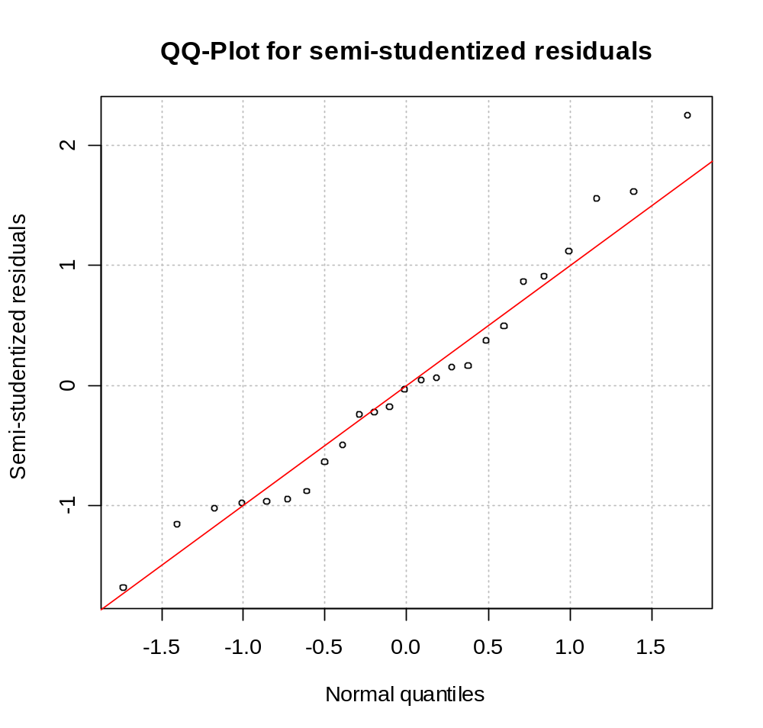

Statistical package implementations of QQ-plots do not always give the exact same plot as here. One of the main differences is what to plot for the x-axis. Here, I said that the smallest was the 0.0385 (= 1/(n+1) where n=25) quantile of its distribution. The second smallest was the 0.0769 (= 2/(n+1)) quantile of its distribution. The largest was the 0.9615 (= n/(n+1)) quantile of its distribution. Other implementations of a QQ-plot may use a different formula than i/(n+1) for i = 1, …, n.

What do you think about and normality?

Additional implementations may plot N(0,1) quantiles on the x-axis instead of what I plotted for N(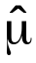, 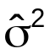) where and are the mean and variance, respectively, of the . If N(0,1) was used instead, the plotted values should still fall on a straight line if had a normal distribution. However, the straight line would no longer be the same. Instead, it would have a y-intercept of and slope of 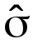.

Why? From your first STAT class, you learned that if X~N(μ,σ²), then Z = (X - μ)/σ ~ N(0,1). Also, notice that X = μ + σZ then.

Finally, R directly implements the QQ-plot with the qqnorm() and qqline() functions. The qqnorm() function draws the plot with N(0,1) quantiles on the x-axis with a different formula for the probabilities used in finding the quantiles. The qqline() function draws a straight line between the 25th and 75 th quantiles. Again, if has a normal distribution, all plotted points should fall on this straight line.

> #QQ-plot
> qqnorm(y = semi.stud.resid)
> qqline(y = semi.stud.resid, col = "red")
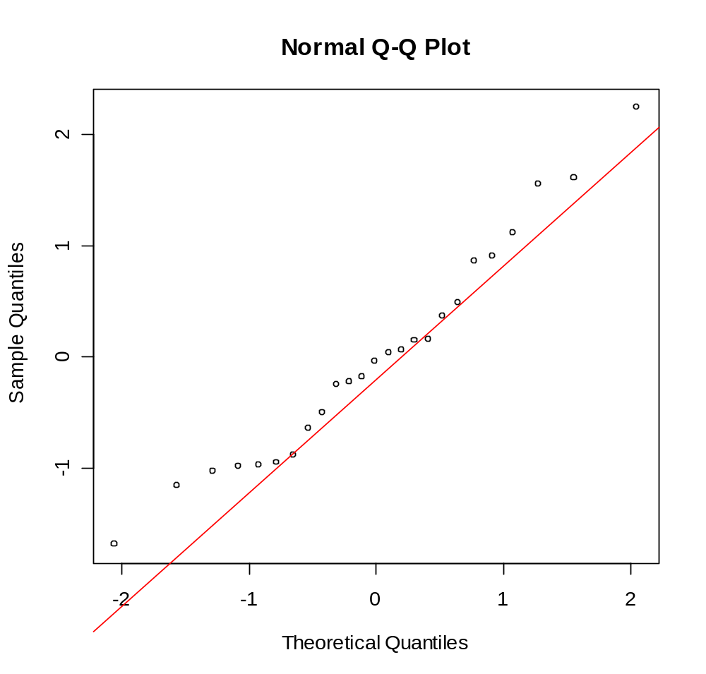

> #What are the qqnorm() and qqline() functions plotting
exactly?
> save.qqnorm<-qqnorm(y = semi.stud.resid, plot = FALSE)
> n<-length(semi.stud.resid)
> save.it<-data.frame(
y.axis = round(sort(save.qqnorm$y),2),
semi.stud.res = round(sort(semi.stud.resid),2),
prob1 = ppoints(semi.stud.resid),
prob2 = (1:n - 1/2)/n,
x.axis = round(sort(save.qqnorm$x),2),
quant.norm = round(qnorm(p = (1:n - 1/2)/n,
mean = 0, sd = 1),2))

> save.it
y.axis semi.stud.res prob1 prob2 x.axis quant.norm
10 -1.69 -1.69 0.02 0.02 -2.05 -2.05
14 -1.16 -1.16 0.06 0.06 -1.55 -1.55
19 -1.03 -1.03 0.10 0.10 -1.28 -1.28
12 -0.98 -0.98 0.14 0.14 -1.08 -1.08
13 -0.97 -0.97 0.18 0.18 -0.92 -0.92
11 -0.95 -0.95 0.22 0.22 -0.77 -0.77
9 -0.89 -0.89 0.26 0.26 -0.64 -0.64
23 -0.64 -0.64 0.30 0.30 -0.52 -0.52
8 -0.51 -0.51 0.34 0.34 -0.41 -0.41

Output edited

2 1.61 1.61 0.94 0.94 1.55 1.55
25 2.25 2.25 0.98 0.98 2.05 2.05

While my original code is better to use, you may use the qqnorm() and qqline() functions in this class.

Comments:
- Overall, assessing normality can be difficult. KNN recommend investigating other departures from the model first before worrying about this. Also, remember that regression analysis tends to be “robust” against departures from normality.
- See p.108 for examples of shapes of a QQ-plot when normality does not exist. Alternatively, simulate observations yourself from a probability distribution and then do a QQ-plot!
- If you have had a mathematical statistics course, see my program for how to use a plot of the cumulative distribution function (CDF) to assess normality.
- How do you solve problems with normality? Often, working with transformations of the response variable, such as log(Y), , and 1/Y, will help induce approximate normality. There are other times where one will need to use more sophisticated types of regression. For example, when Y = 0 or 1 only, logistic regression should be used. This is discussed in STAT 875.
- Often, normality and nonconstant variance problems can be solved simultaneously. I recommend trying transformations as suggested for the nonconstant variance problem first.

- Additional important predictor variables have been excluded from the model

This type of plot will become more important in multiple regression.

Plot e_{i} vs. z_{i} where z_{i} is an additional predictor variable. If there is a pattern in the plot, this suggests that z_{i} should be included in the regression model.

Other notes for Sections 3.3 and 3.9:
- Often more than one of these departures from the model assumptions occurs at the same time! Try to solve one and do the same plots (with transformed model or data) to see if any problems still exist. If they do, continue making changes until the problems have been solved!
- Sometimes it is helpful to introduce a constant in a transformation. For example, suppose Y can be negative. Then taking the log of Y will result in problems. Therefore, using log(Y+c) (where c is an appropriately chosen constant) can overcome this problem. Constants can also be used for transformations for X.

3.8 Overview of remedial measures

Read on your own. Discusses many items already discussed here.

